

**UNIVERSITI TEKNOLOGI MARA**

**Information Science Studies,**

**College of Computing, Information & Mathematics**

**MANAGEMENT OF LIBRARIES AND RESOURCE CENTER**

(IMD315)

**GROUPING ASSIGNMENT:**

Library Proposal of Perpustakaan Pelajar Khas

SMK Undang Rembau

**PREPARED BY:**

|  |  |
| --- | --- |
| Name | Student ID |
| FATIN SYAHIRAH BINTI AHMAD HAMIDI | 2021201386 |
| MUHAMMAD FARIS BIN RIZAL | 2021633726 |
| SITI NORAISYA NOORZA BINTI MOHD TAMRON | 2021891534 |
| UMI MASYITAH BINTI HARUN | 2021830794 |

**PREPARED FOR:**

MOHD NAIM BIN MOHD NASFI

**SUBMISSION DATE:**

26 January 2024

**GROUPING ASSIGNMENT:**

Library Proposal of Perpustakaan Pelajar Khas

SMK Undang Rembau

**PREPARED BY:**

|  |  |
| --- | --- |
| Name | Student ID |
| FATIN SYAHIRAH BINTI AHMAD HAMIDI | 2021201386 |
| MUHAMMAD FARIS BIN MOHD RIZAL | 2021633726 |
| SITI NORAISYA NOORZA BINTI MOHD TAMRON | 2021891534 |
| UMI MASYITAH BINTI HARUN | 2021830794 |

**Information Science Studies,**

**College of Computing, Information & Mathematics,**

**Universiti Teknologi MARA (UiTM) Cawangan Rembau, Negeri Sembilan**

**ACKNOWLDEGMENT**

Assalamualaikum w.b.t

First, I would like to thank Allah S.W.T and His messenger, Prophet Muhammad S.A.W for His mercy and guidance in giving us full strength to complete this task. Even we are facing with some difficulties in completing this task, but we still being able to finish this task with patience, enthusiasm, and co-operation.

We would like to express our sincere gratitude to our lecturer, Mohd Naim Mohd Nasfi for his kindness and high level of patience in answering all of our questions. Her brilliant, skilful supervision enriched this study higher than our expectation. This assignment would not have been possible without the constant support, guidance, and assistance from you.

This project would not have been possible without the support of many people including our friends. We would like to thank them, who directly and indirectly provide us inspirations and valuable suggestion to do this assignment.

Last but not least, our warm and heartfelt thanks go to our family for their tremendous support and hope they had given to us. Without that hope, this assignment would not have been possible. Thank you all for the strength you gave us.

**TABLE OF CONTENT**

|  |  |  |
| --- | --- | --- |
| **NO** | **CONTENT** | **PAGE** |
| 1. | **INTRODUCTION**   * 1. Introduction and Background of Organization   2. Library Theme   1.3 Planning Process (vision, mission and location) |  |
| 2. | **PERSONNEL MANAGEMENT**  2.1 Organization Charts  2.2 Position Descriptions |  |
| 3. | **PERFORMANCE APPRAISALS**  3.1 Objectives of Performance Appraisal  3.2 Appraisal Process / Flowchart  3.3 Appraisal Form / System |  |
| 4. | **FINANCIAL MANAGEMENT**  4.1 Budgeting Techniques  4.2 Sources of Funding |  |
| 5. | **PROMOTIONAL PLANNING**  5.1 Promotional Tools / Media  5.2 Activities Promote Library |  |
| 6. | **DEPARTMENT AND SERVICES**  6.1 Reference Department  6.2 Acquisition Department  6.3 IT Department  6.4 Children Department  6.5 Circulation Department |  |
| 7. | **CONCLUSION & CURRENT ISSUES**  7.1 Roles of libraries in promoting reading culture among society. |  |
| 8. | **REFERENCE** |  |

1. **INTRODUCTION**

1.1 Introduction and background of organization

A library is a place where one may preserve deeply buried historical information as well as learn more about certain themes. Libraries connect a multitude of cultures because their collections, which are available in many community languages, facilitate learning and offer free educational resources to everybody. In the modern world, when a quick internet search might provide a plethora of results, not a single one of which may genuinely address an individual's concern, libraries are invaluable and useful resources. These days, libraries are used for more than just reading books and helping people study for exams. In addition to offering free WiFi and other services, they also include an e-library area where users can use computers and access a variety of video courses. It is vital to examine the physical state of library facilities as well as library services and programmes through the perspective of various patron groups in order to provide equitable opportunity for all library users.

Library provides education and literacy for all of its pupils, including those with impairments, regardless of age. All citizens should have access to the nation's libraries. The areas around the library, the entrance, the restrooms, the stairs, the elevators, and the designated rooms ought to be handicapped-accessible. Individuals with disabilities are able to reach the location, approach the library, and securely enter the facility. A backup accessible entry with a phone, a ramp, and an automatic door opener should be provided if the main entrance cannot be made accessible.

The library is accessible throughout. A floor plan should be prominently displayed at the entry, and the area properly organised with clear signage. The locations of service desks near the entrance. Wheelchairs can travel the entire length of the library. If the library is multi-story, there need to be a ramp or a wheelchair-accessible elevator. Every door should have an automatic opener, and there shouldn't be any doorsteps. Shelves should ideally be accessible to wheelchair users. There should be a specific amount of computer workstations and tables that are wheelchair accessible. The library offers impaired pupils at least one lavatory.

All library materials ideally be accessible for all students especially students with disabilities. There are special media formats for persons with disabilities such as talking books, talking newspapers, and talking periodicals, large print books, easy-to-read books, braille books, video/DVD books with subtitles and/or sign language, e-books, and tactile picture books.

Background Of Perpustakaan Pelajar Khas SMK Undang Rembau.

Perpustakaan Pelajar Khas SMK Undang Rembau were established in 2019. It was established by the principle of SMK Undang Rembau, Tn. Jalaludin bin Dzulkafli. It took around 1 year and a half to build the library with full facilities for the students. Basically, Perpustakaan Pelajar Khas SMK Undang Rembau is provided to help our disabled students to have access in the library. We make sure that all of our students got every single chance to use the materials, that is because we build a library that fully furnished for the easeful of our disabled students. The surroundings of the library, the entrance, restrooms, stairs, elevators and special rooms are accessible for persons with different kinds of disabilities. A person in a wheelchair can reach all departments, a visually impaired person are able to walk with a cane or a guide dog and find his way without bumping into obstacles. A deaf person could also communicate with the library staff and same goes with mute one. Other than that, a person with dyslexia or other reading problem should have no problem to find his way to access for the information in our library.

Perpustakaan Pelajar Khas SMK Undang Rembau provide few materials that ideally accessible for all students. The libraries acquired talking books, video/DVD books, easy-to-read books or other non-print materials. Library staff did know about borrowing such materials from other libraries. It is provided base on amount of disabled people in SMK Undang Rembau. Computers for the other students are accessible too for our disabled students in this school. Fast and reliable technical support are available for both computers and adaptive equipment.

Making the library accessible for persons with disabilities includes the provision of services and programs that meet the needs of these user groups. Communication between library staff and patrons need to be clear and concise. Accessibility to the library should be a clearly defined management responsibility. A designated employee should act as liaison person with disability groups and support organizations. It is, however, important that all staff be knowledgeable about various types of disabilities and how to best assist the patron. Staff should also communicate directly with the patron and not through the caregiver. That is why we trained our staff to have enough knowledge about the library users’ needs and also know how to communicate with them.

* 1. **LIBRARY THEME**

Disabled-friendly school library.

* 1. **PLANNING PROCESS**
     1. VISION

Make sure the comfort of our special students.

* + 1. MISSION

Perpustakaan Pelajar Khas SMK Undang Rembau is committed in making sure all students have the access to information in school library especially the students with disability. We make sure that the facility provided will help the students in many ways in order to satisfy our goals.

**1.3.3** MAPS AND LOCATION

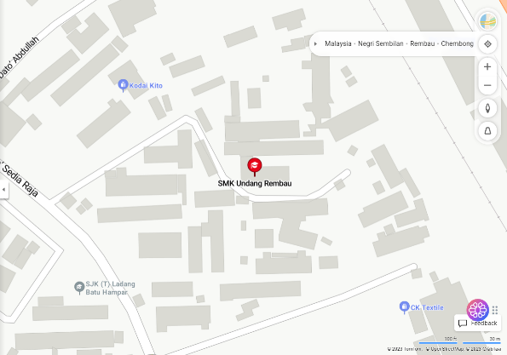

SMK Undang Rembau, Jalan Mampong, Rembau, 71309, Rembau, Negeri Sembilan.

**2.0 PERSONNEL MANAGEMENT**

2.1 ORGANIZATIONAL CHARTS

2.2 POSITION DESCRIPTIONS

1. PRINCIPAL

A primary leader in a school building. A good leader always leads by example. A principal should be positive, enthusiastic, have his hand in the day-to-day activities of the school, and listen to what his constituents are saying.

1. VICE PRINCIPAL

In larger school systems, a head teacher principal is often assisted by someone known as a vice-principal, deputy principal, or assistant/associate principal. Unlike the principal, the vice-principal does not have quite the decision-making authority that the principal carries.

1. GUIDANCE COUNCELOR

A professional who works in schools or other educational institutions, providing academic, personal and career advice to students. They help examine their students’ potential skills to build their self-esteem for success in their future endeavours.

1. HEAD DEPARTMENT

Include planning events to promote the school and its programs, such as dancers or fundraisers. Interviewing candidates for teaching positions and making hiring decisions based on the candidates’ qualifications and cultural fit with the school community.

1. TEACHER

As an educator, a person who helps students to acquire knowledge, competence, or virtue, via the practice of teaching. Informally the role of teacher may be taken on by anyone.

1. ASSISTANT TEACHER

Aids in the design and delivery of lessons by the instructor and promotes student learning. Teacher assistants might have full-time or part-time jobs. Before they may work with students, they must often pass exams, however it's not necessarily necessary to have a formal university degree.

**PERFORMANCE APPRAISALS**

3.1 Objectives of Performance Appraisal

A leader's inspection review of an employee is called a performance appraisal. One of the main things that each organization does every year is evaluate each employee's productivity in relation to their overall contribution to the firm. This is the point at which leaders compile all performance data collected through employee assessments. The goal is for the leader to be able to recognize the accomplishments, advancement, interest, and growth of the staff members. Assisting the organization in providing feedback to each employee so they may argue and exchange ideas on their personal growth is crucial. Leaders can therefore determine whether an employee has a chance to advance or needs to improve if they ever fall behind schedule. In addition, leaders have the authority to determine whether to terminate employees with a poor reputation or those with a lot of merit. In general, a performance review may identify an employee's areas of strength and weakness over a given period of time.

3.2 Appraisal Process / Flowchart

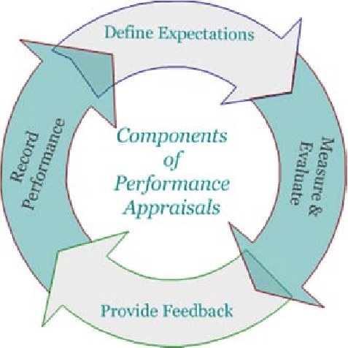

Figure: Appraisal Process

Define expectations is the first step in the appraisal process. What tasks employees must complete and the extent of the work. It is the duty of managers to explain what they want for the company in this situation. The manager will establish the KPI, or key performance indicator, which offers comprehensive strategic planning. The approach comprises goal-setting, providing results and objectives, spending quality time with employees, and monitoring worker development advancement. Additionally, it assists managers in moving employees to the appropriate department according to their training, main ability, and specific fields of experience in order to avoid assigning low-performing employees. Because workers can attach any supporting documentation to the form, the KPI system offers precise documentation of their progress. They also assist employees in understanding the purpose of the task they are assigned and why it must be completed in order to let them know what goals they have set for themselves this year. In order to make better decisions in the future, managers can also benefit from measuring all of their employees' productivity. Not to mention, rules and agreements should be established to prevent employee misconduct. As a result, both the management and the employee will be ready to handle any circumstance that might occur while achieving the goals if the aim is carefully planned.

Second, measurements and evaluations are taken. As is evident, the library conducts twice as many events annually. June is when the first is taken, and December is when the last one is. This is due to the fact that it's essential for managers to look for and monitor employee growth. They can guarantee that every employee is in sync and that their KPI is improving. The worker should be able to make more than 60% of the progress at this point. Employees who are still well behind the average target might seek assistance from their boss by consulting with them. Additionally, supervisors need to constantly encourage their staff members to never give up because, by working as a team and understanding one another, any issues may be resolved.

Thirdly, the managers need to give feedback of the employee working performance after the evaluation. As stated above, there are twice evaluation of employee in a year. So that, managers need to give feedback or comment of employee performance to them to know the strength and weakness that they need to be improve for the future. Encouragement for instance, is beneficial for employees who require additional training. Managers can always provide training to their staff to stay up to date with the rapid developments in today's technologies. As a result, it may inspire employees to advance their development more. However, if they have been employed by the company for a considerable amount of time, employees who perform well may talk more about potential job promotions in the future.

Lastly, managers must record the employee performance after evaluation session. So that, the managers and employee have evidence that can be as a proof to be promoted in future. It is very important thing that need to be taken seriously. Other than that, all the document and records need to be included in the employee's personal file for future reference by other organizations. Then, bonuses and rewards are provided and given to the employees who perform well at work.

3.3 Appraisal Form / System

An appraisal form is used to evaluate the performance of employees. The form should start with the employee's name, the examiner's name, their signature, and the time and date of the exam. A sample well-performance appraisal form that the ... can use for employee and staff development is shown in the picture below. An individual employee who achieved a 75% KPI is the example given. The agreed target, full mark, target accomplish, staff achievement, score, and mark are all included in the table. The marks range from bad to good. This technique ensures worker fairness by specifically evaluating each worker's performance. As a result, appraisals can influence managers' future decision-making regarding the necessary actions for their employees. Additionally, libraries might evaluate online resources in order to stay updated with technological standards. Their data is preserved in this way, making it simple to recover it in the future. It can be accessed by employees via their official website.

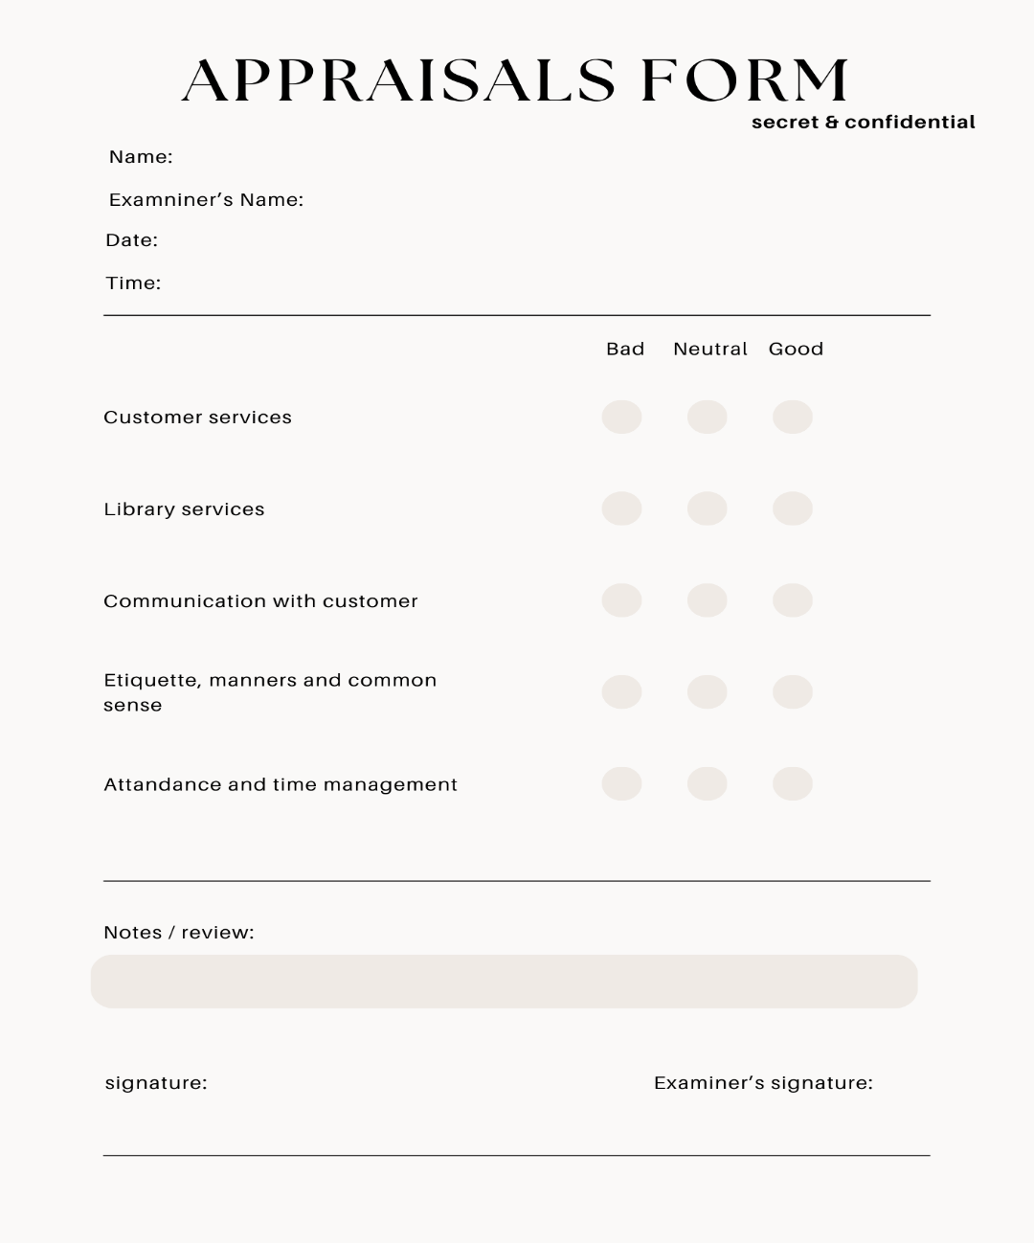

Figure: Appraisals Form

|  |  |  |  |  |
| --- | --- | --- | --- | --- |
| No. | Employee Target | Full Marks | Achievement | Score |
| 1. | Customer service | 20% | 17% | Good |
| 2. | Library service | 20% | 15% | Good |
| 3. | Communication with customer | 20% | 17% | Good |
| 4. | Etiquette, manners and common sense | 20% | 18% | Good |
| 5. | Attendance and time management | 20% | 18% | Good |
| TOTAL | | 100% | 85% | Excellent |

85 / 100 = 85% (KPI Mark.)

This candidate exceeded his or her performance appraisal which score above 75%. Thus, this employee can be rewarded.

**FINANCIAL MANAGEMENT**

Financial has always been an important component of nearly every library. The management team of the library must control operations, and in certain circumstances monitor and maintain the facility's budgets. Budget requirements, budgeting, and resource maintenance are all freely traded by the library. However, it seems to call for a property extension. The most successful and efficient method of managing the library's finances is through Zero Based Budgeting (ZBB). Zero-based budgeting, as defined by Peter Pyhrr (1970), starts at the beginning of any budget cycle, evaluates the demands that come with each position within the organisation, and distributes the financial development towards economic growth, no matter how much has already been budgeted for any given budget item. ZBB makes it possible to include high-level, critical strategies within the budgeting process by linking them to specific functional divisions within the NADA agency.

Because of its complete nature, zero-based budgeting may be implemented over a period of many months, with administrators or department heads periodically evaluating some of its basic characteristics. Through the elimination of general increases or decreases from the previous year's budget, zero-based budgeting can assist in cutting costs. despite the fact that it requires a lot more time and effort than standard cost-based financial management. In addition, practice supports industries with direct sales or productivity growth since these areas can more easily verify their work than departments like research and development and customer service.

Step on Zero Based Budgeting (ZBB).

1. **Define the Budgeting Period:** Clearly establish the time frame for the budgeting period. Whether it's an annual, bi-annual, or another cycle, having a specific timeframe is crucial for the ZBB process.
2. **Identify Decision Units:** Break down the library's operations into decision units or functional areas. In a library context, these units could include acquisitions, cataloguing, circulation, reference services, technology, staffing, and so on.
3. **Analyse Current Operations:** Evaluate the existing operations of each decision unit. Understand the costs associated with personnel, resources, technology, and any other relevant expenses. This involves a thorough review of all activities and their associated costs.
4. **Set Priorities and Objectives:** Clearly define the library's priorities and objectives for the upcoming budgeting period. What are the key goals and outcomes that the library aims to achieve? Align these priorities with the overall mission and strategic objectives.
5. **Cost Identification and Justification:** For each decision unit, identify and justify all costs from scratch. This means re-evaluating every expense and determining whether it aligns with the library's objectives. Each cost should be justified based on its necessity and contribution to achieving the library's goals.
6. **Rank and Prioritize:** Prioritize decision units based on their alignment with the library's objectives and goals. This step helps in allocating resources more efficiently to areas that contribute most significantly to the library's mission.
7. **Allocate Resources:** Allocate resources based on the justified costs and priorities. This may involve redistributing resources from lower-priority areas to higher-priority ones, ensuring optimal use of the budget.
8. **Monitor and Review:** Implement a system for monitoring and reviewing budgetary performance throughout the budgeting period. This ensures that resources are being used efficiently and effectively.
9. **Continuous Improvement:** Encourage a culture of continuous improvement. Periodically reassess operations, identify cost-saving opportunities, and refine the budgeting process based on lessons learned.

The advantages and disadvantages of using Zero Based Budget (ZBB).

**ADVANTAGES**

1. **Increased Efficiency:** ZBB requires a thorough examination of each budget line item, promoting a detailed understanding of costs. This often leads to increased efficiency as unnecessary or redundant expenses are identified and eliminated.
2. **Resource Optimization:** The budgeting process starts from scratch, allowing for a more strategic allocation of resources. This ensures that funds are directed toward areas that contribute most significantly to organizational goals.
3. **Aligns with Strategic Objectives:** ZBB encourages a direct link between budget allocations and strategic objectives. By re-evaluating costs in line with organizational priorities, it helps ensure that resources are used to achieve the organization's overarching goals.

**DISADVANTAGES**

1. **Resource-Intensive:** Implementing ZBB requires a significant amount of time and resources. The detailed analysis and justifications for each line item can be time-consuming, making it a resource-intensive process.
2. **Complexity and Skill Requirement:** ZBB demands a high level of financial and analytical skills. Organizations without the necessary expertise may find it challenging to implement and sustain the process effectively.
3. **Potential for Bias:** The budgeting process involves human judgment, and there's a risk of biases influencing decisions. Personal opinions and political factors may impact the evaluation of certain line items.

4.2 Sources of Funding

**Federal Funds.**

there are potential sources of funds from government entities for establishing a library for students with special abilities:

1. **Ministry of Education (MOE):** Check if the Ministry of Education has grants for projects enhancing educational resources for students with special needs.
2. **Department of Social Welfare (JKM):** Explore grants from JKM, which oversees social welfare programs, including those for individuals with disabilities.
3. **National Library of Malaysia (PNM):** While not direct funding, PNM may offer support or resources for projects related to library development for individuals with special abilities.
4. **Malaysian Association for the Blind (MAB) and Disability Associations:** Connect with NGOs like MAB, which might provide information on available grants or support in accessing funding.

Engage with relevant authorities, NGOs, and local education networks to explore available funding opportunities for your initiative. Stay informed about evolving policies and programs that may impact funding sources.

**State Aid for library.**

State Aid to Libraries would involve financial support provided by the government to libraries across the country including our library. For example:

1. **Government Support:** The proposed Special Abilities Library will seek support and recognition from relevant government bodies, including the Ministry of Education and the Department of Social Welfare in Malaysia.
2. **Funding Allocation:** We aim to secure funding from government grants and programs that support initiatives focused on enhancing educational resources and services for individuals with special abilities.
3. **Eligibility Criteria:** The library will adhere to specific eligibility criteria set by the government, ensuring that it provides open access, employs qualified staff, and offers a diverse range of resources tailored to individuals with special abilities.
4. **Application Process:** The library will submit a comprehensive application detailing its mission, objectives, and plans for utilizing government funds to create an inclusive and accessible environment for individuals with special abilities.
5. **Review and Approval:** The overseeing authorities will review the application, assess the library's alignment with state goals, and approve the allocation of funds for the establishment and operation of the Special Abilities Library.
6. **Resource Utilization:** Funds will be utilized to procure specialized materials, adaptive technologies, and create spaces within the library that cater to the unique needs of individuals with special abilities.
7. **Monitoring and Reporting:** The library commits to regular reporting on fund utilization and outcomes achieved, ensuring transparency and accountability in line with government expectations.
8. **Performance Evaluation:** The government may establish performance metrics, such as increased accessibility, community engagement, and educational outcomes, to evaluate the impact of the Special Abilities Library on its target audience.

In conclusion, this proposal seeks government support to establish a Special Abilities Library in Malaysia, emphasizing inclusivity, accessibility, and educational enrichment for individuals with special abilities.

**PROMOTIONAL PLANNING**

5.1 Promotional Tools / Media

A marketing tool that can help you create an effective marketing plan and enhance your company is promotional planning. Other than that, Promotion is a marketing strategy that aims to raise awareness and develop a positive outlook in the target market, the community, and other business-related groups as well as our special student library. Then, we also using a few promotion strategies as well as tools to raise knowledge about the school library and to make improvements to it.

In a nutshell advertising is a one-way communication that aims to teach potential special students or users about the library and its services, as well as how to access them. This is the purpose of the promotional and marketing tools or media that we employed to promote and advertise our special student library. Additionally, there are many of other advertising tactics. We used to utilize school events, electronic digital platforms like the school website and the website for our special student library, and social media platforms like WhatsApp to tell parents of special students to come to our library event in order to promote our services or activities.

We advertise our services and notify users about our events held at the library on the library's own website. Borrowing is one of the services that we offer in our library. Users and students are welcome to check out books and other resources from our library. as CDs, audiovisual devices, and many others. We believe that we have around 700 books and collections in our library, covering a wide range of topics from major local publishers. Religion, language, academic subjects, general knowledge, and many other topics were covered. Two copies of books or any other allowed material may be borrowed by users at once, with a seven-day read period.

Apart from that, in our special student library also provide special class or additional class for our students or users who want to learn about how to find books or materials and how to use special materials such as braille book, audio form and many more. This is also one of our initiatives to attract users to come to our special student library and attract any potential organization or company to give contribution to our library.

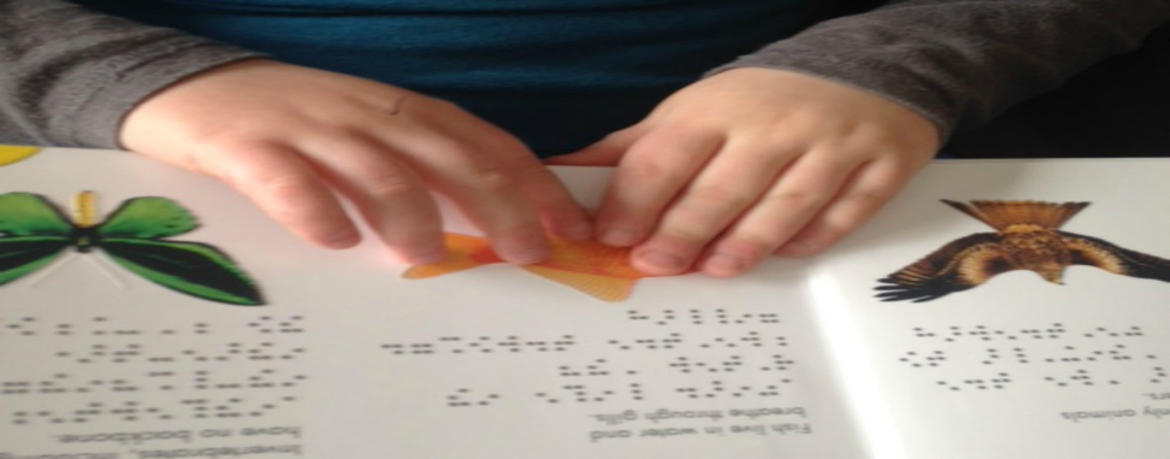Figure: Example of Braille Book

5.2 Activities Promote Library

Our special student library also hosts outreach program and social responsibility events as part of its promotion of the library. We shall be doing a program called "Lawatan ke Pusat Jagaan Kanak-kanak Sinar Bakti" as one of our activities. to get more knowledge about special education students and how to communicate with them in a way that the library can use. Aside from that, the Programme also aims to improve the digital and technological capabilities of our special student library.

In my opinion, there are some other suggestions and program that can be doing to promote our library. In order to promote our library, it is also can reach some contribution in other organization or company that can help our library to make an improvement in our library such as adding more collection or materials and doing many more event for our library. Like stated above, one of our events is doing additional classes to users or students who interested to know on how to find materials and how to use and handle special materials such as braille book, audio form and many more. In this kind of event teach user new knowledge and give exposure to them about the materials or collection.

In addition, the special student library will hold a "Reading 10 minutes" event, a regular event held in any library. The goal is to ensure that every user or student reads a book on that day, even if it is just ten minutes. This type of method can teach readers and develop the nature of loving books, knowledge and reading.



Figure: Poster of event “Reading 10 minutes”

**DEPARTMENT AND SERVICES  
6.1 Reference Department**

6.1.1 Background

The Reference Department is a department that provides reference services to library visitors who want to obtain the desired information. Through this department, guidance on finding materials, advisory services related to book collections in the library and assistance in finding materials can be carried out. Not only that, this reference department has been fully responsible for meeting the information needs of users. So basically, the importance of this department in the school library is to offer help to teachers and students and specially to disabled students who will use this library since it is a mandatory facility in the school. So, it is a bit of a loss for school users not to take advantage.

6.1.2 General policies for user

These are the general policies that have been planned in the reference department for users:  
1) Accessibility

This accessibility means that the reference department should be easily accessible to users, especially for disabled children. Space, equipment, and reference materials have been ensured to be easy to use and comfortable for all users.  
2) Personal Assistance

Provide personal assistance or special services to children with disabilities who need additional guidance or support in finding reference materials. These will be known as OKU friends who offer special services for people with disabilities.

3) Courses and Training for Staff

Provide courses and training for library staff to understand the needs of disabled children and provide appropriate assistance.

4) Special Program

Maintain special programs or activities that are conducted in an inclusive manner to ensure that children with disabilities can participate without barriers.

5) Time Flexibility

Providing flexibility in the period of borrowing or access to reference materials, giving space to children with disabilities to carry out their activities without excessive time pressure

6.1.3 Department chart

Figure: Department chart for Reference Department

6.1.4 Techniques used

For the main target users of this library, namely the disabled, this department has provided additional services for this group, namely the presence of a disabled buddy who will act as a mobile reference department. The purpose of the existence of this OKU buddy is to help the OKU group to know more about the book collection provided. They don't have to bother after this to walk to the counter themselves to get reference information, but only must ask their own OKU buddy.

**6.2 Acquisition Department**

6.2.1 Background

The acquisition department is a department that will manage the selection of books in more detail in the various formats available including digital formats. This process will involve selection based on collection basis, pre-order catalog searches, ordering materials, receiving, quality assessment, invoice processing, payment, and maintenance of acquisition records. Acquisitions are carried out according to functions such as cataloging and collection management which will be responsible for obtaining all aspects of the materials required.

6.2.2 General policies for user

These are the general policies that have been planned in the acquisition department for users:  
1) Accessible Format

Ensure that materials acquired by the library are available in a variety of accessible formats, such as large print, Braille and digital formats compatible with assistive technology.

2) Assistive Technology

Determine that acquired materials should be compatible with common assistive technologies to ensure customers with disabilities can access and interact with content effectively.

3) Training for Library Staff

Implement a policy for ongoing training of library staff to increase their awareness of accessibility issues, including the use of assistive technology and serving patrons with various types of disabilities.

4) Accessibility of Interlibrary Loan

Develop guidelines to ensure that materials obtained through interlibrary loan services are also available in accessible formats or can be easily converted to accessible formats upon request.

6.2.3 Department chart

Figure: Department chart for Acquisition Department

6.2.4 Techniques used

To ensure the smooth running of the acquisition department, the assessment of needs will be assessed first. This is because, if there are many disabled users will visit the library more often, so it is a duty to add more collections of items that will help them. So, they can together use the items in the library without hindrance and of course there will be financial savings here.

**6.3 IT Department**6.3.1 Background

The Information Technology (IT) Department in a library is responsible for managing and maintaining the technology infrastructure and systems that support library operations and services. This department has an important role in ensuring that library technology works efficiently, providing access to digital resources, maintaining the library database, managing computer systems, and supporting technology-related services for both library staff and visitors. The IT department in a library generally deals with tasks such as network administration, hardware and software maintenance, handling technical problems, implementing new technologies, and ensuring the security of digital information. Overall, the IT department has a key role in leveraging technology to enhance library functionality and improve user experience.

6.3.2 General policies for user  
This policy is to ensure that its use is safe and that all users can benefit from it. This is the policy that has been set and among them:

1) Internet and Network Access

Establish guidelines for Internet use and network access, including blocking inappropriate websites.

2) Information Security

Emphasize the importance of maintaining the confidentiality of information and encourage users to guard the entry of passwords and personal information.

3) Mobile Device Management

Establish policies regarding the use of mobile devices in the library, including the use of cell phones and tablets. It can also make it easier for disabled users to use it.

4) Use of Software and Applications

Provide guidance related to the use of OKU-friendly software and applications and ensure that the necessary licenses or permits have been obtained.

5) Hardware Operation

Set guidelines regarding the use of computers and IT devices and report any damage or loss immediately.

6.3.3 Departmental chart

Figure: Departmental chart for IT Department

6.3.4 Tools used

In this department, it is important for there to be awareness training about the development of technology that is friendly to the disabled. When there is technological progress that is friendly to the disabled, they will not feel marginalized in the education sector. Not only that, through this training, other users or librarians themselves will be more alert to the needs and challenges faced by disabled users in the IT field. In addition, there is a need for software adaptations that are comparable to today's technology and it must be updated from time to time.

**6.4 Children Department**

6.4.1 Background

The Children's Section in a library is a section or area devoted specifically to meeting the needs and interests of library users who are children, usually from infants to pre-teens. This section focuses on providing a supportive and engaging environment for children to explore literature, learn, and develop a love of reading. Key features of the Children's Section often include age-appropriate book collections, interactive learning materials, educational programs, storytelling sessions, and friendly spaces for young readers and their families. The goal is to stimulate early literacy, encourage a lifelong love of reading, and support the educational and recreational needs of children in the community. The Children's Division may also organize events, activities, and initiatives aimed at promoting literacy and learning in a fun and accessible way.

6.4.2 General policies for user  
These are the general policies that have been planned in the children's department:

1) Security and Surveillance

Set guidelines on the safety of children in the library, including supervision by guardians or library staff while they are in the library especially for children with disabilities.

2) Access to Children's Specific Materials

Ensure that there is a specific area in the library that provides reading materials and media that are appropriate for the age of the children.

3) Play Area and Physical Activity

Explain the play area, games, or physical activities provided for children and outline the relevant rules because if someone and the child are in the library for too long, they will get bored and will eventually make a ruckus in the library and can bring various risks.

6.4.3 Departmental chart

Figure: Department chart for Children Department

6.4.4 Tools used

There are many activities that disabled people can do together with the children department and among them is a reading session together. In this session, reading materials will be selected by the children's department since they are more knowledgeable about children. Not only that, they can even invite some famous children's book writers to narrate their books themselves. In addition, the circulation department can also hold a special program for the disabled children themselves where in this program the people around them will know how to effectively handle them.

**6.5 Circulation Department**

6.5.1 Background

The Circulation Department in a library refers to the department or unit responsible for managing the return and borrowing of library materials. It involves the process of registering library members, giving and collecting books, and maintaining borrowing records. This section also deals with fines or late payments for borrowed materials. The Returns Division plays an important role in ensuring that library materials can be accessed and used efficiently by library members.

6.5.2 General policies for user  
These are the general policies that have been planned at the circulation department:

1) Borrow-Borrow Procedure

Clarifying the procedure for borrowing library materials, including the loan period, loan limit, and how to extend the loan period. However, for people with disabilities, the return date and loan method may use different methods.

2) Online Facility

Explains how to use the online system to make reservations, check loan status, and make fine payments.

3) Additional Equipment

Determining how to use and manage additional equipment such as line magnifiers, card readers, or other assistive technology devices and using braille on items in the library so that people with disabilities can also enjoy them together.

4) Borrowing Priority

Clarifies borrowing priorities for staff, teachers, and students, as well as how to deal with priorities for educational purposes.

6.5.3 Departmental chart

Figure: Departmental chart for Circulation Department

6.5.4 Activities used

The circulation department can hold activities that involve the participation of the disabled themselves. Circulation department can create a disabled-friendly return machine where it only uses a layout specifically for disabled users. With the existence of this machine, it has been believed that the library will be visited more and more and surely users will find it easier to use it without any assistance.

**7.0 CONCLUSION AND CURRENT ISSUES**

7.1 Current issues of the roles of libraries in promoting reading culture among society.

When planning a new library for a significant purpose, it becomes a crucial element in the success criteria. Durable flooring, excellent lighting, and effective ventilation play a vital role in enhancing the library's versatility and adaptability for future generations. A library serves as a communal space that adds value to our cultural lives by offering information, entertainment, and access to a variety of books, music, and movies that may be otherwise unaffordable. Libraries are unique spaces where individuals are free from conventional constraints since reading is entirely a matter of personal choice. Users are allowed to peruse what they like and read books according to their preferences without interference. The quiet and organized environment allows users to absorb more information in less time.

A library, as a space for storing books and information sources, facilitates easy access for various purposes. Libraries are both convenient and cost-effective, incorporating books, magazines, journals, DVDs, manuscripts, and more. They offer a wide range of activities for individuals of all ages, providing free education and entertainment to the masses. Libraries are excellent places for learning. To keep up with the growing volume of information, libraries need to embrace technology, adapting to changing times. This involves making improvements to satisfy user needs and expectations, ensuring easy access to materials. Librarians and staff must undergo training to enhance their knowledge and skills, incorporating digital tools such as online document delivery, interlibrary borrowing forms, virtual reference services, and more. Utilizing technology can not only reduce storage needs but also make the library environment more efficient and effective.

Conclusion

In conclusion, opening a library designed for students with special abilities has great potential to create a supportive and inclusive learning environment. This tailored library will offer accessible resources, educational materials, and assistive technologies, enhancing the academic experience for these students. Beyond academics, it promotes community, belonging, and empowers students to thrive in their education. This proposal aligns with principles of inclusivity, education, and empowerment for students with special abilities.

**REFERENCE**

*ResearchGate*. (2024). ResearchGate; ResearchGate. https://www.researchgate.net/figure/Performance-Appraisal-Process_fig1_321652896/download?_tp=eyJjb250ZXh0Ijp7ImZpcnN0UGFnZSI6Il9kaXJlY3QiLCJwYWdlIjoiX2RpcmVjdCJ9fQ

‌